Enable Multi-Factor Authentication for VPN

- Go to below URL and sign in with your speridian Credentials.
https://aka.ms/mfasetup
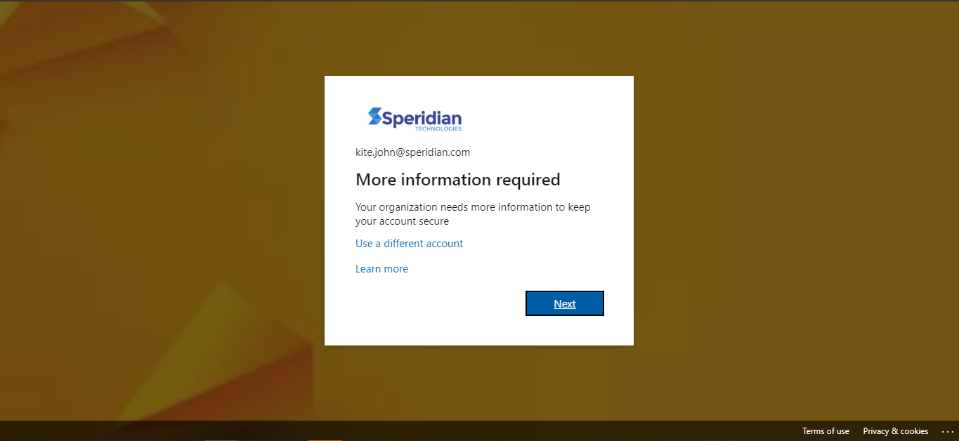
- Click on Next.

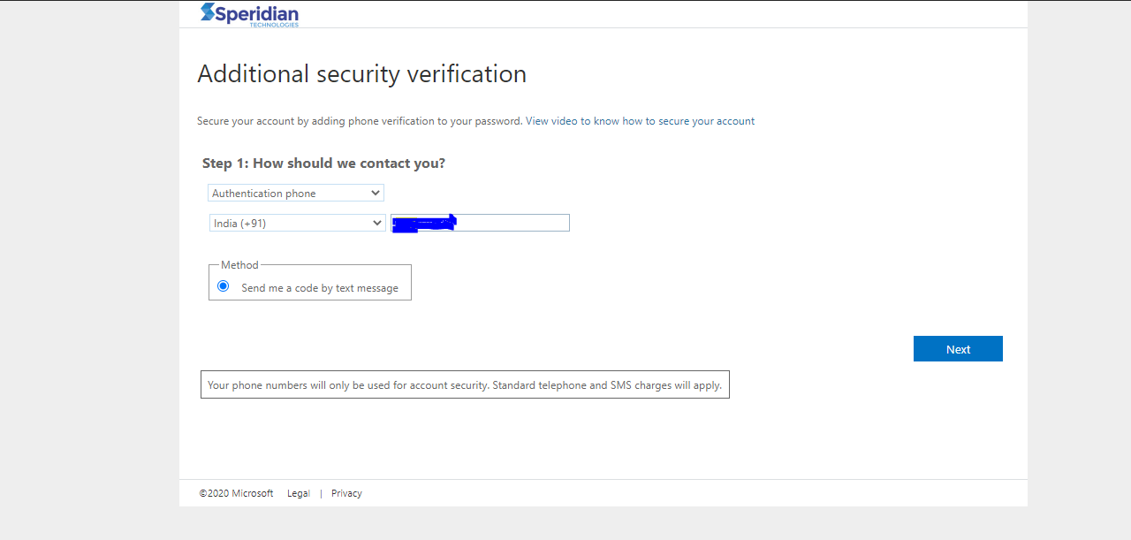
- Select “Authentication Phone”, your Country, Phone Number. Click Next

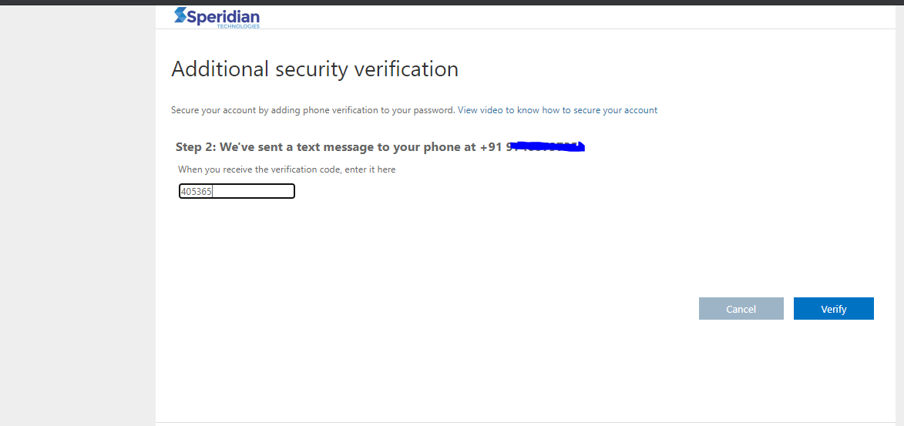

- Verify your Phone with OTP received on your Phone.
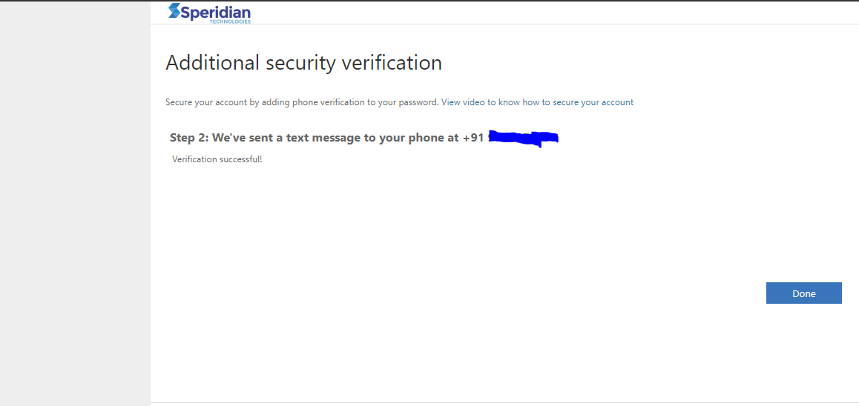

- Click Done. Now your Account has been enabled with MFA.

Connect to VPN

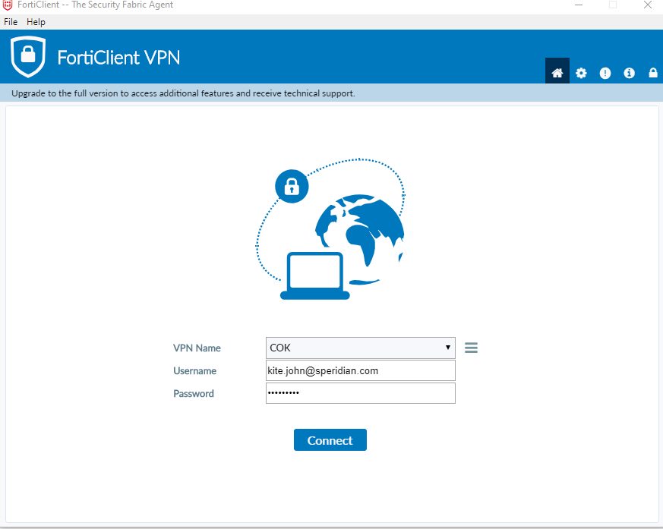

- Enter speridian credentials for connecting to VPN, Click Connect.
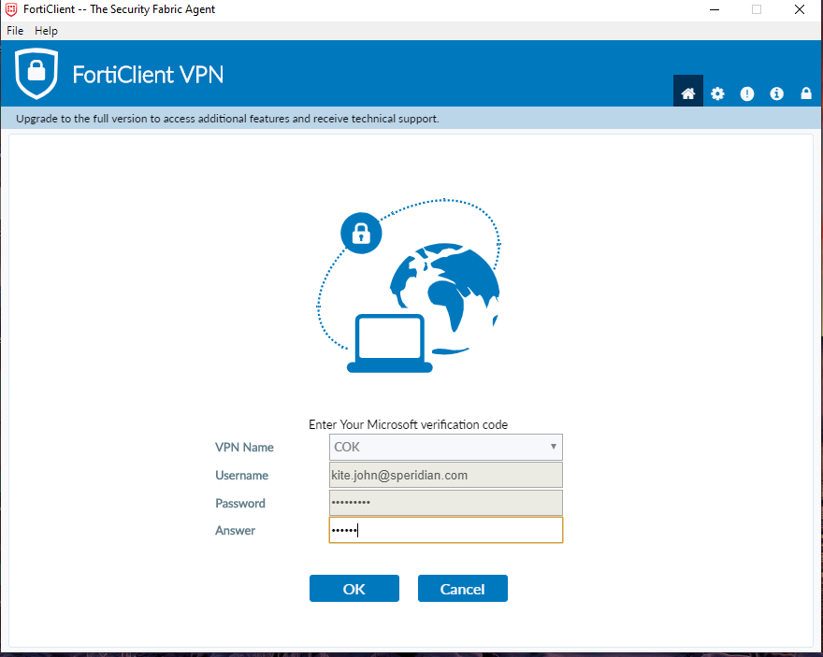
Enter your six-digit Verification code (OTP) in “Answer” Box, and click “OK”
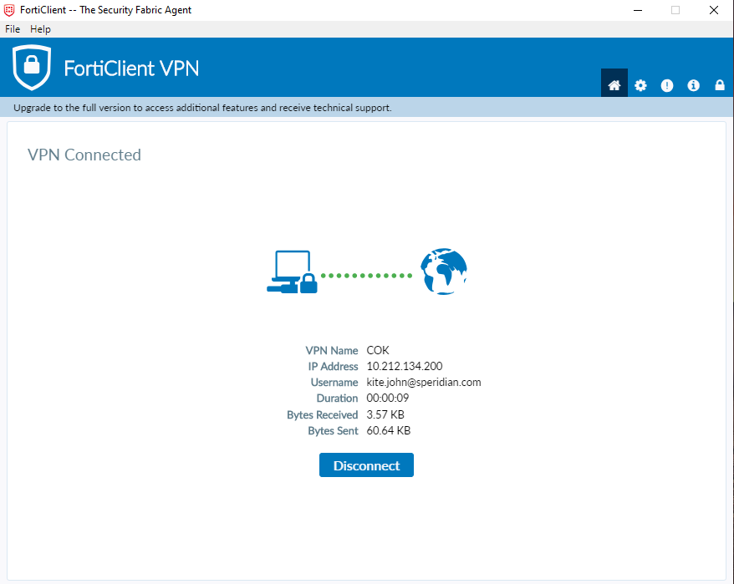

You will successfully connected to Speridian VPN with MFA Security.

